O.P. JINDAL SCHOOL, SAVITRINAGAR, TAMNAR
SESSION- 2020-21
SUBJECT- EVS
Class: II
Topic: Clothes we wear Date:24/07/20

Match the following:
- Kashmir

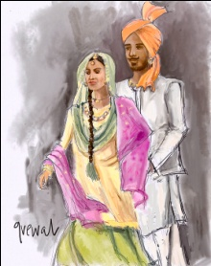
- Bengali

- Rajashthan 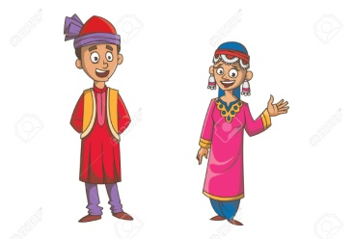

- Punjab 