O.P. JINDAL SCHOOL, SAVITRINAGAR, TAMNAR
SESSION- 2020-21
SUBJECT- EVS
Class: II
Topic: Clothes we wear Date:31/07/20

Write one line about the job done by each of them:
- Weaver
The weaver weaves the thread into clothes.
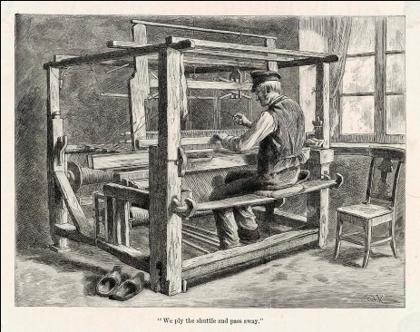
- Tailor
The tailor stitches the clothes.

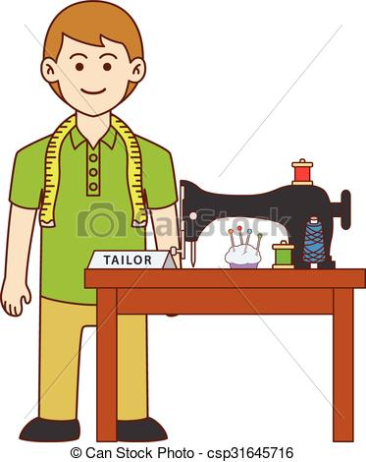

- Washerman
Washerman washes our clothes in the laundry.

