O.P.JINDAL SCHOOL, SAVITRINAGAR, TAMNAR
SESSION- 2020-21
SUBJECT- EVS
Class: II
Topic: Keeping safe Date:04.08.20

Match the signs with their meaning:

- 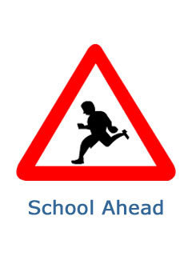 a) Railway crossing.

- 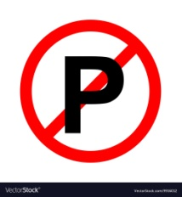 b) No horning.

- 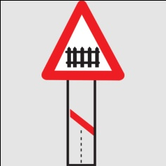 c) School ahead.

- d) No parking.

