O.P.JINDAL SCHOOL, SAVITRINAGAR, TAMNAR
SESSION- 2020-21
SUBJECT- EVS
Class: II
Topic: Keeping safe Date:07.08.20

Look at the picture below and write down four safety rules that children should follow:
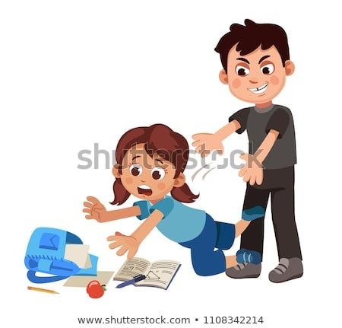

- Don’t fight.

- Don’t run in the classroom.

- Don’t jump on the table.

- Don’t push others.

